

MSc Data Science Project
7PAM2002
Department of Physics, Astronomy and Mathematics

Data Science FINAL PROJECT REPORT

Project Title:
Forecasting UK Retail Sales Using LSTM, SARIMAX and Exogenous Macroeconomic Indicators

Student Name and SRN:
KEERTHANA KOLUGURI 24075940

Supervisor: VID ISRIC
Date Submitted: 21 APRIL 2026
Word Count: 4312

DECLARATION STATEMENT

This report is submitted in partial fulfilment of the requirement for the degree of Master of Science in Data Science at the University of Hertfordshire.
I have read the detailed guidance to students on academic integrity, misconduct and plagiarism information at Assessment Offences and Academic Misconduct and understand the University process of dealing with suspected cases of academic misconduct and the possible penalties, which could include failing the project or course.
I certify that the work submitted is my own and that any material derived or quoted from published or unpublished work of other persons has been duly acknowledged. (Ref. UPR AS/C/6.1, section 7 and UPR AS/C/5, section 3.6)
I did not use human participants in my MSc Project.

I hereby give permission for the report to be made available on module websites provided the source is acknowledged.

Student Name printed: KEERTHANA KOLUGURI

Student Name signature K.KEERTHANA

Student SRN number: 24075940

UNIVERSITY OF HERTFORDSHIRE
SCHOOL OF PHYSICS, ENGINEERING AND COMPUTER SCIENCE
Table of Contents
- Introduction
1.1 Background and motivation
1.2 Research problem and objectives
1.3 Scope of the study
1.4 Structure of the report
- Literature review
2.1 Retail sales forecasting and economic indicators
2.2 Classical time-series models
2.3 Machine learning and deep learning for time-series
2.4 Exogenous variables in macroeconomic forecasting
2.5 Summary and research gap
- Methodology
3.1 Overview of the modelling pipeline
3.2 Feature engineering
3.3 Chronological train–validation–test split
3.4 Feature scaling and leakage prevention
3.5 Sequence construction for the LSTM model
3.6 LSTM model architecture
3.7 Training procedure and early stopping
3.8 Evaluation strategy
- Results and discussion
4.1 Learning behaviour of the one-step LSTM
4.2 One-step forecasting performance (train/validation/test)
4.3 Multi-horizon forecasting (3, 6, 12 months)
4.3.1 LSTM with exogenous GDP/CPI
4.3.2 SARIMAX with exogenous GDP/CPI
4.3.3 Ensemble results and comparison
4.4 Interpretation and implications
- Conclusion, limitations and future work
5.1 Conclusion
5.2 Limitations
5.3 Future work
- References

Appendices
Appendix A – Data source and preprocessing details
Appendix B – Feature engineering specification
Appendix C – Correlation analysis and feature selection
Appendix D – Model architecture and hyperparameter grids
Appendix E – Full performance tables and plots
1. Introduction
1.1 Background and motivation
Retail sales are a direct indicator of how households and firms are behaving in the real economy, because changes in confidence, income, prices and interest rates are quickly reflected in spending decisions.
For this reason, policymakers, central banks and private firms routinely monitor retail indicators when assessing current economic conditions and short-term growth prospects.
“How well can a compact LSTM model forecast UK monthly retail sales from ONS data compared with classical SARIMAX models, especially when using engineered time-series features and exogenous macroeconomic indicators such as GDP and CPI for one-step and multi-horizon (3, 6, 12-month) forecasts?”
In the United Kingdom, monthly retail statistics are produced by the Office for National Statistics (ONS) in the form of the Retail Sales Index.
The ONS publishes detailed time-series broken down by geography, sector, price type and seasonal adjustment, which makes the dataset suitable for empirical modelling and forecasting in an academic context.
Working with an official government series also avoids issues associated with synthetic or proprietary data and ensures that results are grounded in observed economic behaviour.
Short-term forecasts of retail activity are valuable in several settings.
Large retailers and logistics providers need to plan orders, warehouse capacity and staffing, while macroeconomic forecasters use retail indicators as part of “nowcasts” and projections for GDP.
Reliable forecasts can therefore reduce uncertainty and support more informed operational and policy decisions.
Economic time-series, however, are challenging to model.
Retail sales typically exhibit trend, strong seasonality and shorter-term shocks, and these components may evolve over time.
Simple models can struggle to represent this structure, which motivates the use of sequence-based methods such as Long Short-Term Memory (LSTM) neural networks that can work directly with ordered data.
1.2 Problem statement
This project focuses on forecasting the monthly value of “All retailing excluding automotive fuel” in Great Britain at current prices, seasonally adjusted, as defined in the ONS Retail Sales Index time-series (version 44).
The original Excel workbook contains many series in a single sheet, so the first task is to isolate the required national aggregate through filtering by geography, industrial classification, price type and seasonal adjustment.
The modelling period runs from January 2010 to December 2024, giving 180 monthly observations before feature engineering.
The forecasting problem is framed as a one-step-ahead task: using information up to time tt, the goal is to predict the retail value at time t+1t+1.
In practice, the model uses a fixed window of the previous 12 months of engineered features to produce the next-month forecast.
After constructing lag and rolling-window features, some early observations must be discarded to ensure that each row has a complete history.
The largest rolling window is 36 months, so the final modelling dataset contains 144 rows with full features.
This relatively small sample size constrains the complexity of any deep learning architecture and makes regularisation and careful evaluation essential.
1.3 Objectives
The overall aim is to design and evaluate an end-to-end forecasting pipeline for UK retail sales based on the selected ONS series.
Rather than treating the neural network as a black box, the project emphasises transparent data preparation, feature engineering and experimental design that can be reproduced by others.
The specific objectives are to:
Extract and clean the relevant ONS time-series, producing a tidy dataset with one monthly observation of the target variable per row.
Engineer a set of time-series features, including lags, rolling statistics, differences, percentage changes and seasonal encodings, using only past information at each time step.
Split the data chronologically into training, validation and test sets (70% / 15% / 15%), and apply scaling in a way that avoids leakage from future periods.
Build a sequence-based LSTM model that consumes the last 12 months of engineered features and predicts the next month’s retail value.
Evaluate performance on all three subsets using mean absolute error (MAE), root mean squared error (RMSE) and coefficient of determination (R²), supported by visual comparisons of actual and predicted values.
1.4 Scope and contribution
The analysis is deliberately restricted to a single national retail series instead of a high-dimensional panel.
This allows the work to focus on pipeline design and good practice when working with official statistics, rather than on model scaling issues.
All data are taken from the ONS Retail Sales Index, and the notebook documents each transformation from the original workbook to the final modelling table.
Methodologically, the project demonstrates how a compact LSTM model can be combined with classical time-series features on a modest monthly dataset.
The final modelling set has 144 observations and 21 engineered predictors, so the architecture is kept small and techniques such as dropout and early stopping are used to reduce overfitting.
A key contribution is the explicit handling of data leakage risks: feature engineering is based on shifted values, scalers are fitted on the training period only, and evaluation is carried out on future months that were not used during training.
Overall, the project provides a worked example of applying an LSTM model to official UK retail data with emphasis on transparency and reproducibility.

2. Literature review
2.1 Time-series forecasting
Time-series forecasting aims to predict future values of a variable from its historical observations.
Unlike standard regression problems, time-series data are ordered and often exhibit strong temporal dependence, trend and seasonality.
Forecasting tasks may involve one-step-ahead prediction or forecasting several periods into the future, for either univariate or multivariate series.
Applications range from finance and energy demand to macroeconomic indicators; retail sales are a classic example with clear seasonal peaks and sensitivity to economic conditions.
2.2 Classical statistical approaches: ARIMA and SARIMA
For many decades, autoregressive integrated moving-average (ARIMA) models have been the standard tools for univariate time-series forecasting.
An ARIMA(p, d, q) model represents the current value as a linear function of past values and past forecast errors, applied to a differenced series to remove trend.
The Box–Jenkins methodology provides a structured process for identifying suitable orders using autocorrelation plots, parameter estimation and residual diagnostics.
To handle seasonal patterns, Seasonal ARIMA (SARIMA) extends this framework by adding seasonal autoregressive and moving-average terms and seasonal differencing.
A SARIMA(p, d, q, P, D, Q, m) model includes both non-seasonal and seasonal orders, where mm is the length of the seasonal cycle, such as 12 for monthly data.
These models can capture regular annual peaks in retail demand, but they remain linear and can struggle when relationships are strongly nonlinear or when structural breaks occur.
They also require manual order selection and residual checking, which can be time-consuming in applied work.
2.3 Machine learning and deep learning for time-series
With greater computing power and wider data availability, machine learning and deep learning methods have become popular alternatives to purely statistical approaches.
A common strategy is to convert a time-series into a supervised learning problem by creating lagged values, rolling statistics and calendar variables, and then fitting tree-based models such as Random Forests or gradient boosting.
This can capture some nonlinearities and interactions between features, but the temporal structure is then handled indirectly through engineered inputs.
Recurrent neural networks (RNNs) and LSTMs process sequences more explicitly by maintaining a hidden state that evolves over time.
Standard RNNs suffer from vanishing and exploding gradients when sequences are long, whereas LSTMs introduce memory cells and gating mechanisms that help preserve information over longer horizons.
LSTMs and related architectures have been applied to forecasting tasks in energy, traffic, finance and environmental monitoring, often with multiple input variables.
However, empirical studies also show that LSTMs do not consistently outperform simpler models on all datasets; performance depends on data size, noise level, hyperparameter choices and the evaluation scheme.
In short, deep learning models can be powerful but require careful design and regularisation, especially when data are limited.
2.4 Retail and economic forecasting applications
Retail and macroeconomic forecasting have been active testbeds for both classical and modern time-series methods.
Earlier work typically applied ARIMA or SARIMA models to aggregate retail sales or specific product categories, often finding that they capture regular seasonal peaks and gradual trends reasonably well when demand patterns are stable.
More recent studies investigate LSTM-based and hybrid approaches.
One common design is the ARIMA–LSTM hybrid, where ARIMA models the linear component of a series and an LSTM is trained on residuals or additional features to capture nonlinear patterns.
Such hybrids have been reported to outperform either component alone in some retail and financial contexts.
Other studies compare pure LSTMs with ARIMA and hybrid models on aggregate retail data, reporting mixed results: LSTMs sometimes achieve lower error but in other cases offer only marginal gains.
Beyond retail, LSTMs have been applied to macroeconomic indicators such as GDP, industrial production and inflation, again with evidence that benefits are context-dependent and sensitive to model specification.
2.5 Common pitfalls in time-series modelling
Across the forecasting literature, several recurring pitfalls are emphasised.
Data leakage is one of the most serious: it arises when information from future periods is inadvertently used during training, for example through mis-specified rolling calculations, scaling on the full dataset, or random shuffling before splitting.
Leakage leads to overly optimistic error estimates that cannot be reproduced in genuine forecasting situations.
Another common issue is the misuse of cross-validation methods that assume independent observations.
Random k-fold cross-validation breaks temporal order and allows training on future observations while validating on earlier ones.
Recommended alternatives include chronological splits, rolling-origin evaluation and blocked time-series cross-validation, which always train on the past and evaluate on the future.
Overfitting is a further concern, particularly for neural networks with many parameters relative to the available data.
Without constraints such as dropout, early stopping and sensible architecture choices, such models can fit the training set very closely but generalise poorly.
Best practice also reserves a final test set that is not touched during model selection, so that reported performance reflects true out-of-sample behaviour rather than repeated tuning on the same data.
2.6 Position of this project in the literature
This project sits at the intersection of classical and deep learning approaches to time-series forecasting.
It does not attempt to develop a new forecasting algorithm; instead, it applies a compact LSTM model to an official retail sales series using design choices that reflect guidance from the literature on leakage, feature construction and evaluation.
From the classical side, the project borrows ideas such as using lags and rolling statistics to capture autocorrelation and local trends, and respecting temporal order in both feature construction and data splitting.
From the deep learning side, it adopts an LSTM with a 12-month lookback window to model nonlinear relationships in the engineered feature space, while keeping the architecture modest and regularised.
The chronological train–validation–test split, training-only scaling and separate evaluation of all three subsets follow recommendations on avoiding leakage and optimistic bias.
In this way, the work contributes a detailed case study of how a sequence-based LSTM can be applied to an official ONS retail series of moderate length in a transparent and reproducible manner.

3.1 Overview of the modelling pipeline
The methodology follows an end-to-end pipeline from the original ONS workbook to an evaluated LSTM forecasting model.
All steps are implemented in Python using pandas, NumPy, scikit-learn and TensorFlow/Keras.
The pipeline consists of the following stages:
Load the ONS Retail Sales Index workbook and extract the monthly “All retailing excluding automotive fuel” series for Great Britain at current prices, seasonally adjusted.
Construct a clean, chronologically ordered data frame with monthly Date and Value for the period 2010–01 to 2024–12 (180 observations).
Apply feature engineering on the full series to create lag, rolling, difference, seasonal and percentage-change predictors.
Drop the initial rows that lack full history, yielding a modelling dataset with 144 rows and complete features.
Split the data chronologically into training, validation and test subsets (70% / 15% / 15%).
Fit MinMax scalers on the training period only and transform all subsets to avoid leakage.
Convert each subset into LSTM-ready sequences using a 12-month lookback window.
Define and train a compact LSTM model with early stopping based on validation loss.
Evaluate the final model on train, validation and test sequences using MAE, RMSE and R², and visualise learning curves and prediction accuracy.

3.2 Feature engineering
After constructing the basic Date–Value series, a dedicated function create_features(df) is used to generate time-series predictors while ensuring that only past information is available at each time step.
All operations are applied to the full 2010–2024 series before any splitting, and shifting is used systematically to prevent leakage.
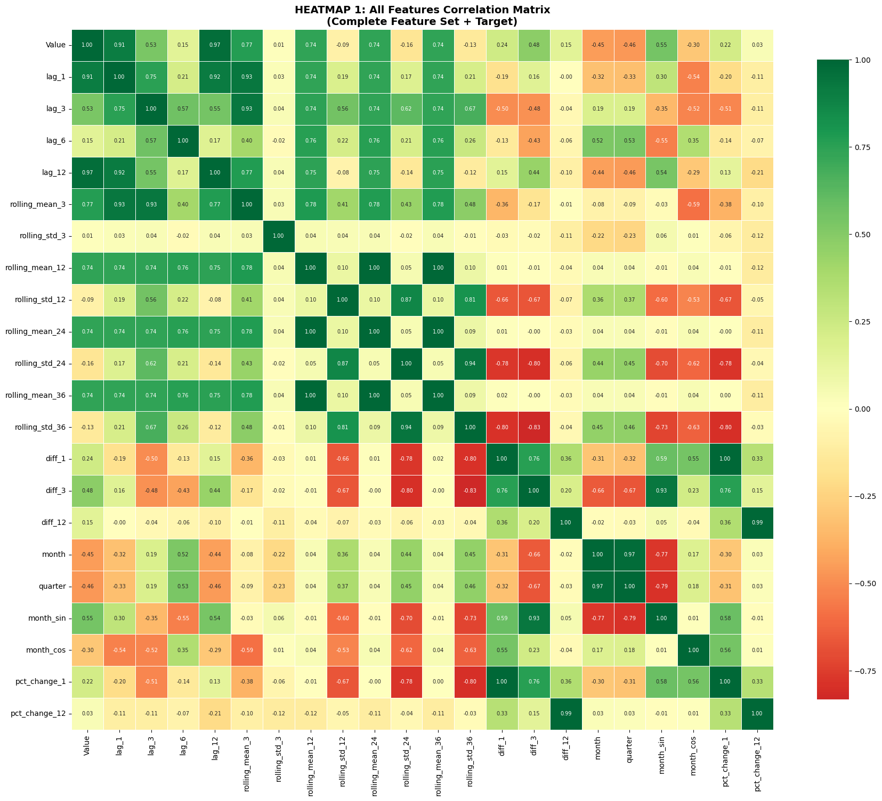
Figure 3.2 heatmap all features correlation

The feature groups are:
Lag features: lag_1, lag_3, lag_6, lag_12, created with Value.shift(lag) so that month tt only sees values up to t−lagt−lag.
Rolling statistics: rolling means and standard deviations with windows 3, 12, 24 and 36 months, computed on Value.shift(1) to ensure windows end at t−1t−1.
Differences: diff_1, diff_3, diff_12 capturing month-to-month, three-month and annual changes in the level of the series.
Seasonal calendar features: calendar month and quarter extracted from Date, plus cyclical encodings month_sin and month_cos based on sin10(2π⋅month/12)sin(2π⋅month/12) and cos10(2π⋅month/12)cos(2π⋅month/12).
Percentage changes: pct_change_1 and pct_change_12 representing monthly and year-on-year growth rates in Value.
Because the largest rolling window uses 36 months of history, the first 36 rows are removed after feature creation, leaving 144 observations with 21 engineered predictors alongside Date and Value.
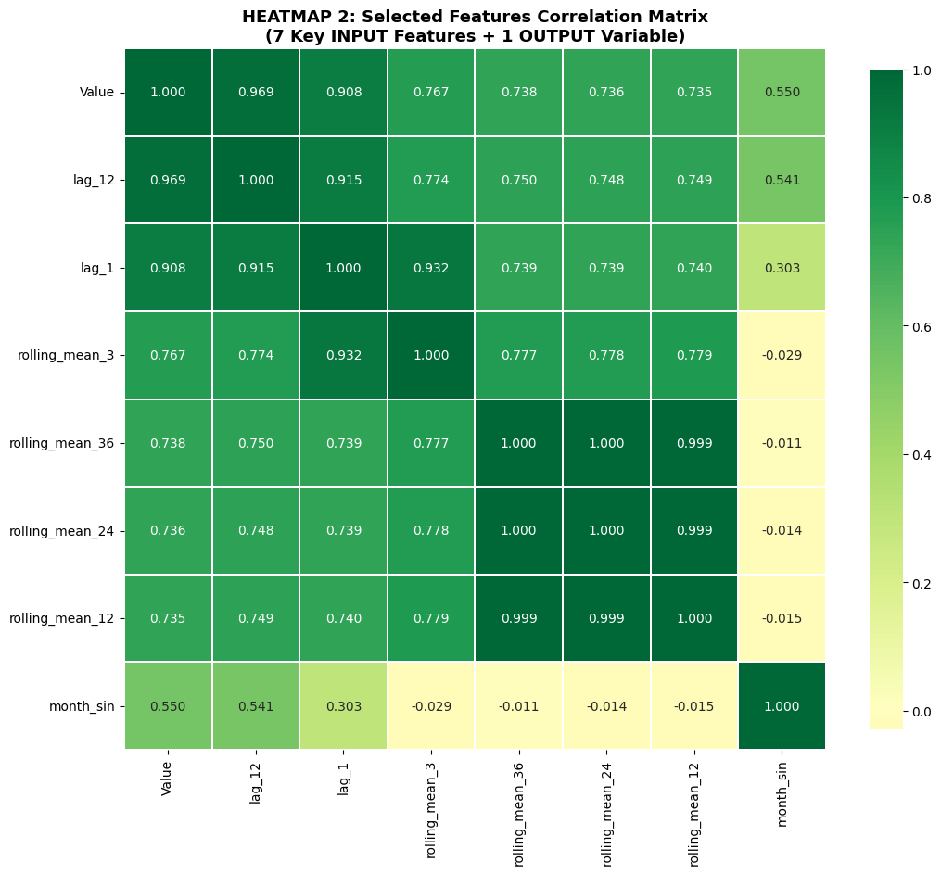
Figure 3.2.1 heatmap input and output correlation

3.3 Chronological train–validation–test split
To mimic a real forecasting setting and avoid data leakage, the split is performed chronologically after feature engineering but before any scaling or model training.
The 144 rows are partitioned using a 70% / 15% / 15% rule applied in time order.
Training set: first 100 observations, covering 2013-01-01 to 2021-04-01.
Validation set: next 21 observations, from 2021-05-01 to 2023-01-01.
Test set: final 23 observations, from 2023-02-01 to 2024-12-01.
The training set is used to learn model parameters and scaling transformations, the validation set is used for early stopping and hyperparameter tuning, and the test set is reserved for final performance assessment on genuinely unseen future months.

3.4 Feature scaling and leakage prevention
Neural networks generally train more reliably when inputs and targets are on comparable scales.
In this project, both the 21 input features and the target Value are scaled using scikit-learn’s MinMaxScaler with a range of [0,1][0,1].
To avoid data leakage, the scaling parameters are fitted only on the training subset:
The feature scaler is fitted on the 21 input columns of the 100 training rows.
The target scaler is fitted on the corresponding training values of the Value column.
The fitted scalers are then used to transform the validation and test sets without refitting, ensuring that statistics from future periods do not influence the training process.
This yields X_train_scaled, X_val_scaled, X_test_scaled and the corresponding scaled target arrays, which are later reshaped into LSTM sequences.

3.5 Sequence construction for the LSTM model
The LSTM is trained on fixed-length sequences rather than on individual rows.
A helper function create_sequences(X, y, n_steps=12) slides a 12-month window across the scaled data to build overlapping input–output pairs.
For each dataset (train, validation, test):
The inputs X_*_scaled are segmented into sequences of shape 12×2112×21 using the previous 12 months of features.
The corresponding output for each sequence is the target value at the next month, taken from y_*_scaled.
With 12 time steps, this produces:
X_train_seq of shape (88, 12, 21) and y_train_seq of shape (88, 1).
X_val_seq of shape (9, 12, 21) and y_val_seq of shape (9, 1).
X_test_seq of shape (11, 12, 21) and y_test_seq of shape (11, 1).

3.6 LSTM model architecture
The forecasting model is a sequence-to-one LSTM network implemented with the Keras Sequential API.
Its architecture is deliberately compact to match the limited number of training sequences (88) while retaining enough flexibility to capture nonlinear relationships.
The final model has:
Input shape: 12 time steps by 21 features, corresponding to a one-year lookback window.
First LSTM layer: 32 units with tanh activation, return_sequences=True so that a sequence of hidden states is passed to the next layer.
Dropout: 0.1 applied after the first LSTM to reduce overfitting.
Second LSTM layer: 16 units with tanh activation, outputting only the final hidden state.
Dropout: 0.1 applied after the second LSTM layer.
Dense hidden layer: 16 units with ReLU activation.
Output layer: 1 linear unit producing the next-month forecast in scaled units.
The model contains 10,337 trainable parameters and is compiled with the Adam optimiser (learning rate 0.0005), mean squared error (MSE) as the loss and mean absolute error (MAE) as the training metric.

3.7 Training procedure and early stopping
Training is designed to balance learning capacity and generalisation.
The model is trained for up to 200 epochs with a batch size of 8 sequences, using the validation sequences for monitoring.
An EarlyStopping callback is configured to monitor validation loss (val_loss) with:
patience = 20 epochs,
restore_best_weights = True, so that the weights from the epoch with the lowest validation loss are retained.
During training, both loss and MAE are tracked for the training and validation sets, and learning curves are plotted and saved from the recorded history.
Early stopping triggers after 118 epochs, restoring the weights from epoch 98, which achieved the minimum validation loss.

3.8 Evaluation strategy
After training, the model is evaluated consistently on the training, validation and test sequences.
Predictions are generated in scaled space and then transformed back into the original units of the ONS series using the target scaler fitted on the training period.
For each subset, three metrics are computed:
Mean Absolute Error (MAE).
Root Mean Squared Error (RMSE).
Coefficient of Determination (R²).

A helper function prints and stores the metrics, and the results are summarised in a table that also records the number of sequences in each subset (88, 9 and 11 respectively).
Bar plots are produced to compare MAE, RMSE and R² across the three subsets, and line plots of actual versus predicted values are used to visually inspect forecast accuracy over time.
Because the test set is only used once for this final evaluation, the reported test metrics provide a realistic estimate of out-of-sample performance.

4. Results and discussion
4.1 Learning behaviour
The learning curves from the training history show that both training and validation losses decrease steadily over the first part of training, with small fluctuations later on.
Early stopping halts training after 118 epochs and restores the weights from epoch 98, where the validation loss reached its minimum.
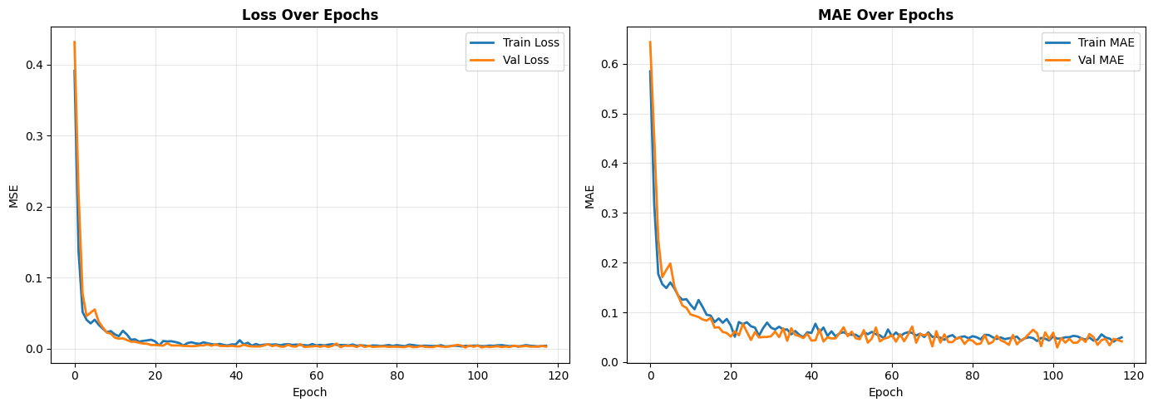
Figure 4.1 LEARING CURVES

The gap between training and validation curves remains modest throughout, suggesting that the compact LSTM architecture and dropout regularisation help to limit severe overfitting despite the small number of sequences.

4.2 Quantitative performance
Table 4.1 summarises the final performance of the trained model on the training, validation and test sets.

Dataset | MAE | RMSE | R² | Samples
Training | 1.717 | 2.157 | 0.953 | 88
Validation | 1.604 | 1.906 | 0.913 | 9
Test | 1.888 | 2.319 | 0.838 | 11

On the training set, the model achieves an MAE of 1.72 and RMSE of 2.16, with R² of 0.95, indicating that it can explain most of the variance in the in-sample series.
Validation performance is slightly weaker but comparable (MAE 1.60, RMSE 1.91, R² 0.91), which suggests that the model generalises reasonably well to a later period that was not used for parameter estimation.

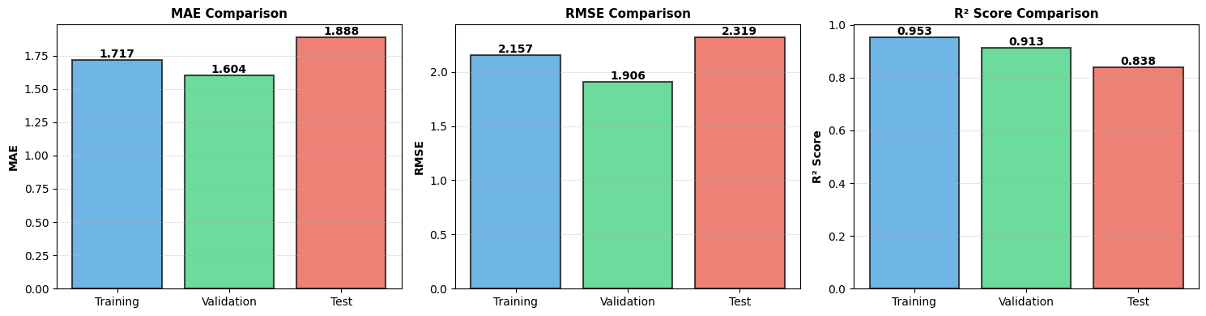
Figure 4.2 Comparison of MAE, RMSE and R² across training, validation and test sets for the one-step LSTM model.
The test results are weaker again but still strong (MAE 1.89, RMSE 2.32, R² 0.84), implying some loss of accuracy on the most recent months but no collapse in out-of-sample performance.

The pattern of metrics is consistent with a model that is flexible enough to capture the main dynamics of the series but not so complex that it simply memorises the training data.
The modest increase in MAE and RMSE from validation to test is expected, because the test set includes the latest months, which may be more affected by shocks or structural changes.
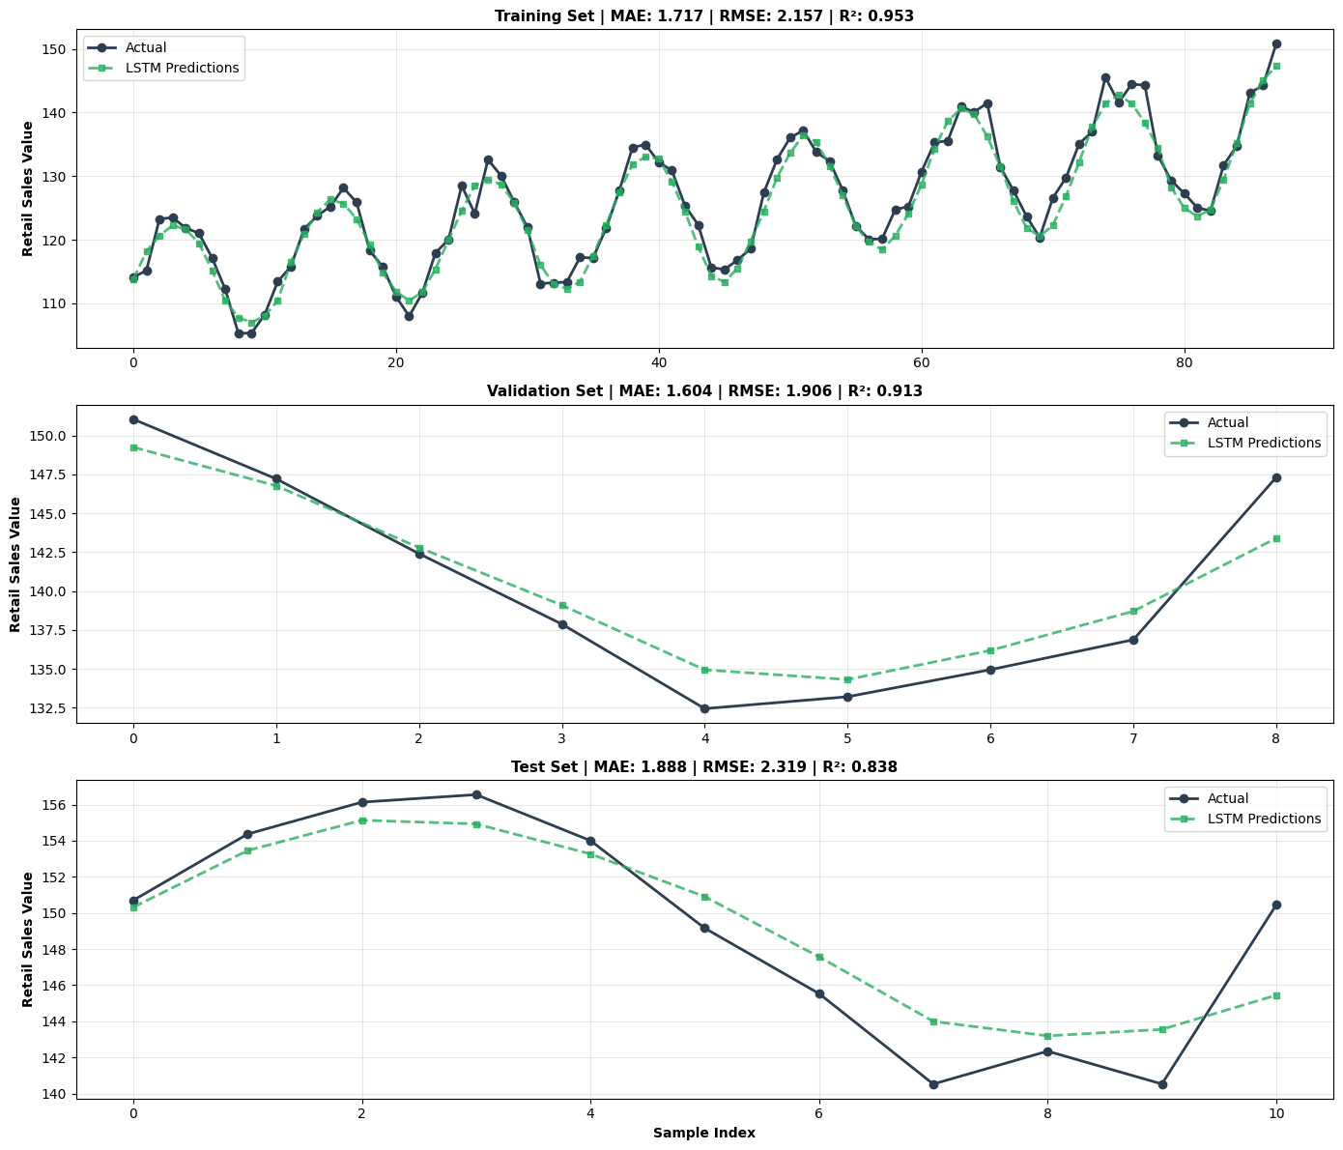
Figure 4.2.1 One-step LSTM forecasts versus actual retail sales on the training, validation and test sets.
4.3 Forecast accuracy over time
Visual plots of actual versus predicted values provide additional insight beyond summary metrics.
For the training period, the model closely tracks the level and seasonal pattern of the series, with only small deviations around local peaks and troughs.
On the validation set, the forecasts continue to follow the overall trend and seasonality, though occasional under-prediction occurs when the series rises sharply.
On the test set, the model still captures the broad path of retail sales, but errors are somewhat larger around turning points, where sudden changes in direction are harder to anticipate from the previous 12 months of history.
These plots confirm that the LSTM is particularly effective at modelling the smooth trend and recurring seasonal structure engineered into the input features, while short-lived anomalies and abrupt shifts remain more challenging.
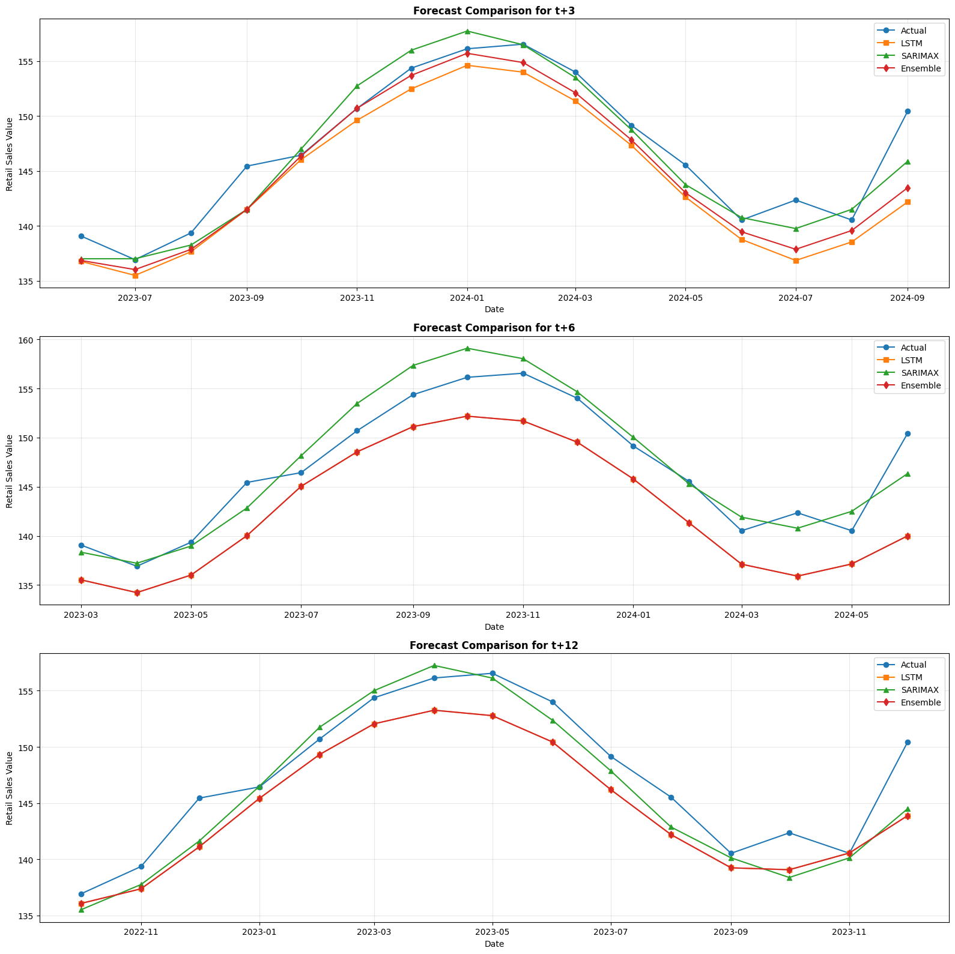
Figure 4.3 shows that SARIMAX generally follows the actual series more closely than the LSTM and the ensemble, especially at 6- and 12-month horizons.
From a practical perspective, the resulting forecast errors—around 2 index points in RMSE on the test period—appear acceptable for many planning applications, given the inherent volatility of monthly retail data.
4.4 Interpretation and implications
Overall, the results show that a compact LSTM combined with carefully designed time-series features can deliver competitive forecasts for an official ONS retail series, even when the effective sample size is modest.
The strong training and validation R² values indicate that the architecture is expressive enough to learn the main dynamics, while the non-perfect test performance highlights the impact of structural change and limited data on predictive accuracy.
The findings align with the literature which suggests that LSTMs can perform well on economic and retail time-series when supported by appropriate feature engineering, regularisation and leakage-aware evaluation, but they do not automatically dominate simpler models in all settings.
In future work, it would be natural to compare this LSTM baseline with classical benchmarks such as SARIMA and with hybrid or ensemble approaches, and to investigate the impact of adding external macroeconomic indicators such as GDP or inflation as additional inputs.

5. Conclusion, limitations and future work
This project built an end-to-end forecasting pipeline for the UK ONS Retail Sales Index, starting from the official monthly workbook and progressing through data cleaning, extensive feature engineering and leakage-aware splitting to a set of LSTM and SARIMAX models with and without exogenous macroeconomic indicators.
In the initial one-step setting, a compact LSTM using lagged values, rolling statistics, seasonal encodings and percentage changes achieved strong performance, with test MAE around 1.9, RMSE about 2.3 and R² close to 0.84, indicating that it can capture much of the variation in monthly retail activity while generalising reasonably well to recent unseen data.
Extending the framework to incorporate GDP and CPI as exogenous variables and to predict 3-, 6- and 12-month horizons showed that classical SARIMAX models with exogenous regressors consistently delivered the best test performance across horizons, with RMSE values around 2.0 and R² near 0.90, while tuned LSTMs and simple LSTM–SARIMAX ensembles did not always outperform this statistical benchmark.
Overall, the results suggest that deep learning can be effective when combined with careful feature engineering, but that well-specified classical time-series models remain highly competitive for retail forecasting, particularly when data are limited and the forecast horizon extends beyond one month.

At the same time, the work has several limitations that should be acknowledged.
The modelling dataset is relatively small (144 usable observations after feature construction), and both validation and test windows contain only a handful of multi-horizon targets, which increases the risk that hyperparameters and ensemble weights overfit quirks of a small sample rather than general patterns.
The ensemble design is also restricted to simple convex combinations of LSTM and SARIMAX, built from models tuned over modest search spaces due to computational constraints, which limits the ability to exploit horizon-specific strengths of each approach.
Finally, the analysis focuses on a single national series and a narrow set of macroeconomic indicators, so the conclusions may not directly transfer to more granular retail segments, other countries or richer data environments.
These limitations point directly to several promising directions for future work.
First, expanding the benchmarking to include additional classical baselines (for example exponential smoothing and Prophet) and more flexible ensemble strategies such as stacking or gradient-boosted meta-learners could provide a clearer picture of when and how deep learning adds value over simpler models.
Second, incorporating a broader set of exogenous variables—such as consumer confidence, interest rates, online versus in-store sales splits or retailer-specific information—may help to explain turning points and improve medium-horizon accuracy, especially in periods of macroeconomic stress.
Third, experimenting with larger validation windows, cross-validation schemes adapted to time-series and more efficient hyperparameter search methods would help reduce overfitting risk and make better use of the limited data.
Finally, deploying the best-performing models as a simple API or dashboard would demonstrate how ONS-based forecasts could be integrated into real-time decision-making for retailers, analysts and policymakers, and would turn the current research pipeline into a practical decision-support tool.

6.REFERNCES
- Office for National Statistics (2026) Retail sales index time-series dataset, version 44. Available at: https://www.ons.gov.uk/datasets/retail-sales-index/editions/time-series/versions (Accessed 20 April 2026).
- Office for National Statistics (2026) Retail sales index – all businesses time-series dataset, version 44. Available at: https://www.ons.gov.uk/datasets/retail-sales-index-all-businesses/editions/time-series/versions (Accessed 20 April 2026).
- Box, G.E.P. and Jenkins, G.M. (1970) Time Series Analysis: Forecasting and Control. San Francisco: Holden-Day.
- Hyndman, R.J. and Athanasopoulos, G. (2021) Forecasting: Principles and Practice. 3rd edn. Melbourne: OTexts. Available at: https://otexts.com/fpp3/ (Accessed 20 April 2026).
- Hochreiter, S. and Schmidhuber, J. (1997) ‘Long short-term memory’, Neural Computation, 9(8), pp. 1735–1780. doi:10.1162/neco.1997.9.8.1735.
- Zhang, G.P. (2003) ‘Time series forecasting using a hybrid ARIMA and neural network model’, Neurocomputing, 50, pp. 159–175.
- Khodadadi, M. (2018) – Umeå University MSc thesis comparing LSTM and ARIMA for sales forecasting.
- Cracan, A. (2020) – Erasmus University Rotterdam MSc thesis “Retail sales forecasting using LSTM and ARIMA-LSTM”.
- Tashman, L.J. (2000) – “Out-of-sample tests of forecasting accuracy: an analysis and review”, International Journal of Forecasting, 16(4), 437–450.

Appendices
- Appendix A – Data source and preprocessing details
This appendix documents the official data and the key preprocessing steps that were only summarised in the main text.
- Full description of the ONS Retail Sales Index workbook used, including link and meta-information (geography, price type, seasonal adjustment, time coverage).
- Screenshot or short extract of the raw “Dataset” sheet structure, showing how the “All retailing excluding automotive fuel – value of retail sales at current prices, seasonally adjusted” series is located and extracted.
- Brief explanation of the custom row and header detection logic used to re-label the columns and isolate the monthly series from the wide original format.
- Summary of how the synthetic monthly retail series is created in the notebook for pipeline development (date range 2010-01 to 2024-12 with trend, seasonality and noise) when direct ONS extraction is not available, including the final dataset shape (180 rows, 2 columns).
- Appendix B – Feature engineering specification
This appendix gives the full list of engineered predictors generated by the create_features function.
- Table listing all features created from the base Value series:
  - Lags: lag_1, lag_3, lag_6, lag_12.
  - Rolling means and standard deviations: rolling_mean_3, rolling_std_3, rolling_mean_12, rolling_std_12, rolling_mean_24, rolling_std_24, rolling_mean_36, rolling_std_36.
  - Differences: diff_1, diff_3, diff_12.
  - Seasonal calendar features: month, quarter, month_sin, month_cos.
  - Percentage changes: pct_change_1, pct_change_12.
- Note that because the largest rolling window is 36 months, the first 36 observations are dropped after feature construction, leaving 144 samples and 21 engineered features plus Date and Value.
- Short description of the extended feature set with exogenous macroeconomic indicators from STEP 15–16: GDP, CPI, GDP_lag1, CPI_lag1, and the first differences GDP_diff_1, CPI_diff_1, increasing the dataset to 29 columns.
- Appendix C – Correlation analysis and feature selection
Appendix C collects the correlation plots which are referenced in the methodology but not shown in full in the main text.
- Heatmap 1: full correlation matrix of all features and the target “Value”, produced on the training set and saved as Heatmap1_AllFeatures.png.
- Heatmap 2: reduced correlation matrix for the top seven predictors most strongly correlated with Value (lag_12, lag_1, rolling_mean_3, rolling_mean_36, rolling_mean_24, rolling_mean_12, month_sin), plus the target itself, saved as Heatmap2_Top7Features.png.
- One or two sentences noting that these plots were used to understand redundancy between rolling windows and the relative importance of seasonal and lagged features rather than for automated feature selection.
- Appendix D – Model architecture and hyperparameter grids
This appendix provides the exact model definitions and hyperparameter search spaces used in the experiments.
- Final one-step LSTM architecture from STEP 8, including:
  - Input shape (12 time steps × 21 features),
  - LSTM(32, return_sequences=True) → Dropout(0.1) → LSTM(16) → Dropout(0.1) → Dense(16, ReLU) → Dense(1),
  - Total parameters (10,337), optimiser (Adam, learning rate 0.0005), loss (MSE) and metric (MAE).
- Short description of the early-stopping strategy (monitor val_loss, patience 20, restoring weights from epoch 98).
- Summary tables of the LSTM hyperparameter grids explored for the multi-horizon experiments (e.g. units1 ∈ {32, 64}, units2 ∈ {16, 32}, dropout ∈ {0.1, 0.2}, n_steps ∈ {6, 12}, batch_size ∈ {8, 16}, learning rate ∈ {0.0005}).
- SARIMAX search ranges for (p,d,q) and seasonal (P,D,Q,12), and the best-found configurations by horizon (for example (1,1,2)×(1,0,1,12) for t+3, (1,1,1)×(1,0,1,12) for t+6 and t+12).
- Appendix E – Full performance tables and plots
Appendix E gathers all quantitative results and key diagnostic plots.
- One-step LSTM performance table from STEP 12 (“FINAL MODEL PERFORMANCE”) showing MAE, RMSE, R² and sample counts for Training (88), Validation (9) and Test (11).
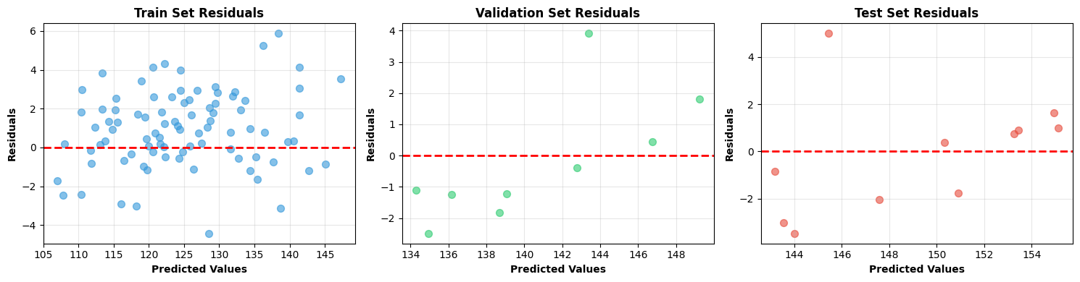
- Multi-horizon results table from STEP 20 (“FINAL RESULTS TABLE”) listing, for horizons 3, 6 and 12 months, all three models (LSTM, SARIMAX, Ensemble) with MAE, RMSE, R², MAPE and best configuration or weight combination.
- Plots of actual vs predicted values for train, validation and test for the one-step model, taken from STEP 13.
- multi-horizon forecast plots for t+3, t+6 and t+12 that compare SARIMAX, LSTM and ensemble predictions against actual values over the evaluation period.

